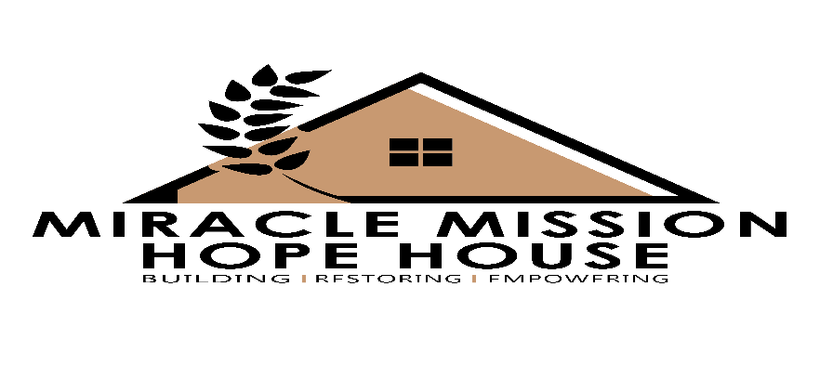

466 Simpson Street McDonough, Ga. 30253● 770- 412-2950●

www.mmhopehouse.net

Understanding Partnership and Impact

Understanding partnership is relevant to working together. It is relationships or bonding between two people or corporations who share a common goal or objective and have joined forces and resources in order to reach their goals and achieve their objectives. It is through partnership that you can share in the goal of this ministry to reach the world with the gospel, eliminate hunger, set the captives free, and reform prisoners. By joining forces and uniting your resources with ours, together we can build a powerful army for the Lord.

Every partnership is considered valuable and we are truly grateful and take nothing for granite. We thank you in advance for deciding to partner with us.

If you have any questions or concerns, please do not hesitate to contact Marlene Lemons, lemons_marlene@yahoo.com or 770-412-2950 or 404-454-9854.

Thank you for your consideration and continued support.
Warmest Regards,
Marlene Lemons
Marlene Lemons, Executive Director
GoFundMe.org/Miracle Mission Hope House
Visit our website: www.mmhopehouse.net
Like us on Facebook/ www.facebook.com/InspiringAuthor MGL
Follow us on Twitter/ @Mmhopehouse
YouTube/www.youtube.com/miraclemissionhopehouse

_ _ _ _ _ _ _ _ _ _ _ _ _ _ _ _ _ _ _ _ _ _ _ _ _ _ _ _ _ _ _ _ _ _ _ _ _ _ _ _ _ _ _ _ _ _ _ _ _

Please Fill out and return to if you would like to mail a check or money order:
Miracle Mission Hope House Inc.
Attn: Ms. Marlene Lemons
466 Simpson Street
McDonough, Ga. 30253

Name_______________________________________________________________

Address_____________________________________________________________

City_______________________________ State______________ Zip____________

Phone__________________________________________________________________

